**第四课时**

**B Let’s learn/Play card games**

**一．教学目标与要求:**

1. 能够听、说、读、写有关健康和建议的单词及词组：wrong, ill, see the doctor, do more exercise, wear warm clothes, take a deep breath, count to ten

2. 能够正确使用上述单词和词组描述身体状况和提供建议。

3. 能根据图片提示完成卡片游戏。

**二、教学重点、难点分析:**  
1. 能够听、说、读、写有关健康和建议的单词及词组：wrong, ill, see the doctor, do more exercise, wear warm clothes, take a deep breath, count to ten。

2. 能够正确使用上述单词和词组描述身体状况和提供建议。

**三、教学准备：多媒体课件，单词图片**

**四、教学步骤和建议:  
Step1．Preparation**

Sing a song <If you’re happy, clap your hands >

**Step2 Presentation**

1. 单词呈现

教师呈现本版块的插图，提问：Who are they ?How does Chen Jie feel ?What should she do ?

1. 教师以同样的方式教do more exercise, wear warm clothes, take a deep breath, count to ten。讨论第二幅图加上问句 What are they doing ?谈论第三幅图可加上What’s the weather like outside ?在教学过程中，用旧词引出新词，同类单词归类和自然拼读的方法帮助学生更快地掌握新单词。
2. 听音正音
3. 小组合作读。

**Step3 .Practice**

1、图片描述能手

2、你问我答游戏

**Step4． Production**

**Play card games**

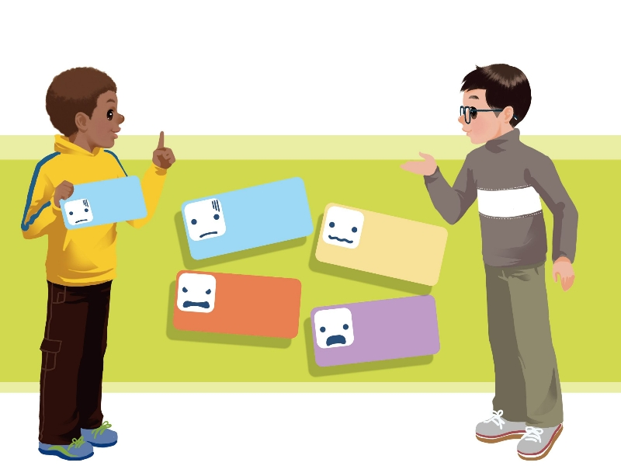What **s**uggestions can you give?

What should I do?

Cold

worried

angry

ill

Cold

You should...

**Step5.Progress**

1、做配套相应的练习。

2、Summary：What have you learned today ?

3、Homework :

1）学生背诵并抄写本课时的四会单词

**板书设计： Unit 6 How do you feel ?**

**You should …**

**see the doctor, do more exercise, wear warm clothes,**

**take a deep breath, count to ten**

**教后感：**